Prequalification Questionnaire for Prospective Contractors

General Instructions
The responses to Section 1 to 4 below by applicants for prequalification shall provide complete, true, accurate and up to date information required to enable the MTR Corporation Limited (the Corporation), Licensed PMC (C-114608), to prequalify a company (the Applicant) to tender for the Contract(s) as described in the Prequalification Questionnaire.

When completing this Prequalification Questionnaire, Applicants shall be aware of the following conditions:

- The Corporation shall treat all responses in this Prequalification Questionnaire as confidential and undertakes not to disclose the responses to others (with the exception of the Corporation's financial, legal and insurance advisors and the Government of Hong Kong Special Administrative Region, as appropriate, during the prequalification and the tender assessment period).

- Completion of the Prequalification Questionnaire shall not bind the Corporation to invite an Applicant to submit a tender and no reasons shall be given for the exclusion of unsuccessful Applicants.

- The composition of the list of tenderers shall rest entirely with the Corporation and its decisions shall be final.

- In the event that the Applicant has or may have a conflict of interest which may affect its judgment in relation to the contract or its ability to properly discharge the works or services to be delivered (including dealings with third parties), then the Applicant shall immediately notify the Corporation as to the nature of the conflict or potential conflict of interest and thereafter shall discuss and agree with the Corporation what action is necessary to resolve the conflict.

- The Applicant shall not, and shall ensure that its directors, employees, agents and subcontractors shall not, offer or give any advantage as defined in the Prevention of Bribery Ordinance (Cap. 201) to any employee or agent of the Corporation. Any breach of or non-compliance of this condition by the Applicant shall, without affecting its liability for such breach or non-compliance, result in its application not being considered.

Applicant shall note the followings:-

- Please fill in all cells highlighted in yellow.
- For Section 2
  - Please submit job reference and clients’ commendation (if any) in Appendix with the Item No.
  - Please insert additional table in same format for more job reference when necessary.

Submitted by
Company name:

Contact person:

Telephone No.:

Email address:

Date:

Section 1
Company Profile
Year of company establishment | Established in ___________  Copy of business and company registration is enclosed.
Organization chart | Submitted in the form of Appendix by referring to Section No.
No. of direct employed staff
Total number of vehicle fleet

Section 2
Item | A. Job Reference in the Past 5 Years for Provision of Laundry Service in particular to hotel, clubhouse, airlines, gymnasiums, property management industry and etc.
1 | Client’s name with contact person, contact no. & email address
 | Contract description
 | Annual contract sum (HK$)
2 | Client’s name with contact person, contact no. & email address
 | Contract description
 | Annual contract sum (HK$)
3 | Client’s name with contact person, contact no. & email address
 | Contract description
 | Annual contract sum (HK$)
4 | Client’s name with contact person, contact no. & email address
 | Contract description
 | Annual contract sum (HK$)
5 | Client’s name with contact person, contact no. & email address
 | Contract description
 | Annual contract sum (HK$)

(Please insert page and table beyond this page for more job reference when necessary)

Item | B. Job Reference in the Past 5 Years for Provision of Dry Cleaning Service in particular to hotel, clubhouse, airlines, gymnasiums, property management industry and etc.
1 | Client’s name with contact person, contact no. & email address
 | Contract description
 | Annual contract sum (HK$)
2 | Client’s name with contact person, contact no. & email address
 | Contract description
 | Annual contract sum (HK$)
3 | Client’s name with contact person, contact no. & email address
 | Contract description
 | Annual contract sum (HK$)
4 | Client’s name with contact person, contact no. & email address
 | Contract description
 | Annual contract sum (HK$)
5 | Client’s name with contact person, contact no. & email address
 | Contract description
 | Annual contract sum (HK$)

(Please insert page and table beyond this page for more job reference when necessary)

Section 3
Others
Has your company worked with MTR Corporation in particular to MTR Properties before? | Yes / No | If Yes, please list out the job details:
Does your company have any Quality Management System? | Yes / No | If Yes, please specify  (e.g. ISO9001 or equivalent)
Does your company have any Quality Management System? | Yes / No | Please provide the related documents, including Quality Management Plan, if any in Appendix.
Does your company have any Safety Management Policy and System? | Yes / No | If Yes, please specify  (e.g. ISO45001 or equivalent)
 | Yes / No | Please provide the related documents, including Safety Management Policy and System, if any in Appendix.
Does your company have any Environmental Management Policy and System? | Yes / No | If Yes, please specify  (e.g. ISO14001 or equivalent)
 | Yes / No | Please provide the related documents, including Environmental Management Policy and System, if any in Appendix.

Section 4
Supplier Code of Practice
Applicant is required to comply with the Corporation’s Supplier Code of Conduct. This provides an ethical and behavioural framework for contractor doing business with the Corporation.
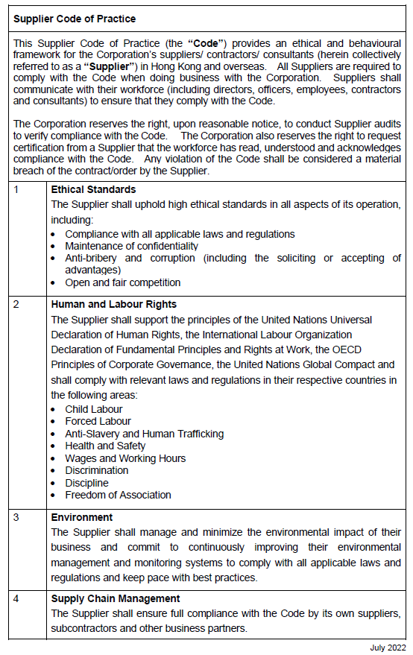

On behalf of the management and staff, I confirm full compliance with this Ethical Code of Conduct.

(to be signed by the Chairman, CEO, Human Resources Director or a member of Senior Management)

Signature: |  |  | Date:
Name / Title: |  |  | Company:
And
Signature: |  |  | Date:
Name / Title: |  |  | Company:

