**Prequalification Questionnaire for Prospective Contractors**

**General Instructions**

The responses to Section 1 to 5 below by applicants for prequalificationshall provide complete, true, accurate and up to date information required to enable the MTR Corporation Limited (the Corporation) to prequalify a company (the Applicant) to tender for the Contract(s) as described in the Prequalification Questionnaire.

When completing this Prequalification Questionnaire, Applicants shall be aware of the following conditions:

1. The Corporation shall treat all responses in this Prequalification Questionnaire as confidential and undertakes not to disclose the responses to others (with the exception of the Corporation's financial, legal and insurance advisors and the Government of Hong Kong Special Administrative Region, as appropriate, during the prequalification and the tender assessment period).
2. Completion of the Prequalification Questionnaire shall not bind the Corporation to invite an Applicant to submit a tender and no reasons shall be given for the exclusion of unsuccessful Applicants.
3. The composition of the list of tenderers shall rest entirely with the Corporation and its decisions shall be final.
4. In the event that the applicant has or may have a conflict of interest which may affect its judgment in relation to the contract or its ability to properly discharge the works or services to be delivered (including dealings with third parties), then the applicant shall immediately notify the Corporation as to the nature of the conflict or potential conflict of interest and thereafter shall discuss and agree with the Corporation what action is necessary to resolve the conflict.
5. The Applicant shall not, and shall ensure that its directors, employees, agents and subcontractors shall not, offer or give any advantage as defined in the Prevention of Bribery Ordinance (Cap. 201) to any employee or agent of the Corporation. Any breach of or non-compliance of this condition by the Applicant shall, without affecting its liability for such breach or non-compliance, result in its application not being considered.

Applicant shall note the following:-

1. Please fill in all cells highlighted in yellow.
2. For Section 2
   1. Please submit job reference and clients’ commendation (if any) in Appendix with the Item No.
   2. Please insert additional table in same format for more job reference when necessary.
3. For Section 3, please insert additional table in same format for more personnel when necessary.

**Submitted by**

|  |  |
| --- | --- |
| **Company name:** |  |
| **Contact person:** |  |
| **Telephone No.:** |  |
| **Email address:** |  |
| **Date:** |  |

**Section 1**

|  |  |
| --- | --- |
| **Company Profile** | |
| Year of company establishment | Established in ___________  Copy of business and company registration is enclosed in Appendix _____, Section No. 1 |
| No. of years of in carpark operation business | Years  Details of carpark business coverage in Hong Kong or elsewhere in Appendix , Section No. 1 |
| Organization chart | Submitted in Appendix , Section No. 1 |
| No. of direct staff employed for carpark operation business |  |
| Name of related companies e.g. holding, sister companies, subsidiaries |  |

**Section 2**

**Job Reference in providing Carpark Operation Business**

(Please list the job reference in descending order in terms of no. of parking space, i.e. from largest to smallest carpark)

|  |  |  |  |  |  |  |
| --- | --- | --- | --- | --- | --- | --- |
| **No.** | **Name of Client** | **Carpark Location** | **No. of Parking Space** | **Contract Period** | **Total Contract Value (HK$)** | **Client’s Commendation / Award (provide supporting document)** |
| 1 |  |  |  |  |  |  |
| 2 |  |  |  |  |  |  |
| 3 |  |  |  |  |  |  |
| 4 |  |  |  |  |  |  |
| 5 |  |  |  |  |  |  |
| 6 |  |  |  |  |  |  |
| 7 |  |  |  |  |  |  |
| 8 |  |  |  |  |  |  |
| 9 |  |  |  |  |  |  |
| 10 |  |  |  |  |  |  |

**Section 2**

**Job Reference in providing Carpark Operation Business**

(Please list the job reference in descending order in terms of no. of parking space, i.e. from largest to smallest carpark)

|  |  |  |  |  |  |  |
| --- | --- | --- | --- | --- | --- | --- |
| **No.** | **Name of Client** | **Carpark Location** | **No. of Parking Space** | **Contract Period** | **Total Contract Value (HK$)** | **Client’s Commendation / Award (provide supporting document)** |
| 11 |  |  |  |  |  |  |
| 12 |  |  |  |  |  |  |
| 13 |  |  |  |  |  |  |
| 14 |  |  |  |  |  |  |
| 15 |  |  |  |  |  |  |
| 16 |  |  |  |  |  |  |
| 17 |  |  |  |  |  |  |
| 18 |  |  |  |  |  |  |
| 19 |  |  |  |  |  |  |
| 20 |  |  |  |  |  |  |

**Section 2**

**Job Reference in providing Carpark Operation Business**

(Please list the job reference in descending order in terms of no. of parking space, i.e. from largest to smallest carpark)

|  |  |  |  |  |  |  |
| --- | --- | --- | --- | --- | --- | --- |
| **No.** | **Name of Client** | **Carpark Location** | **No. of Parking Space** | **Contract Period** | **Total Contract Value (HK$)** | **Client’s Commendation / Award (provide supporting document)** |
| 21 |  |  |  |  |  |  |
| 22 |  |  |  |  |  |  |
| 23 |  |  |  |  |  |  |
| 24 |  |  |  |  |  |  |
| 25 |  |  |  |  |  |  |
| 26 |  |  |  |  |  |  |
| 27 |  |  |  |  |  |  |
| 28 |  |  |  |  |  |  |
| 29 |  |  |  |  |  |  |
| 30 |  |  |  |  |  |  |

**Section 3**

|  |  |  |
| --- | --- | --- |
|  | **Strength and Quality of Resources (Key Staff)** | |
| 1 | Name |  |
|  | Position | General Manager |
|  | Years of Relevant Experience |  |
| 2 | Name |  |
|  | Position |  |
|  | Years of Relevant Experience |  |
| 3 | Name |  |
|  | Position |  |
|  | Years of Relevant Experience |  |
| 4 | Name |  |
|  | Position |  |
|  | Years of Relevant Experience |  |

**Section 4**

|  |  |  |  |
| --- | --- | --- | --- |
| **Others** | | | |
| Has your company worked with MTR Corporation before? | □ Yes  □ No | If Yes, please list out the job details with the Corporation : | |
|  | |
|  | |
|  | |
|  | |
|  | |
|  | |
| Does your company have any Quality Management Plan? | □ Yes  □ No | If Yes, please specify  *(e.g. ISO9001 or equivalent)* |  |
| Enclosed as Appendix ___________ | |
| Does your company have any Environmental Management Plan? | □ Yes  □ No | If Yes, please specify  *(e.g. ISO14001 or equivalent)* |  |
| Enclosed as Appendix ___________ | |
| Does your company have any Safety Management Plan &/or Safety Policy Statement? | □ Yes  □ No | If Yes, please specify  *(e.g. ISO 45001 or equivalent)* |  |
| Enclosed as Appendix ___________ | |
| Training Scope & Methodology | □ Yes  □ No | Enclosed as Appendix ___________ | |
| Staff Relationship Management System | □ Yes  □ No | Enclosed as Appendix ___________ | |
| Proposal for Human Resources Management Plan and Retirement Scheme | □ Yes  □ No | Enclosed as Appendix ___________ | |

**Section 5**

**Supplier Code of Practice**

Applicant is required to comply with the Corporation’s Supplier Code of Conduct.  This provides an ethical and behavioural framework for contractor doing business with the Corporation.

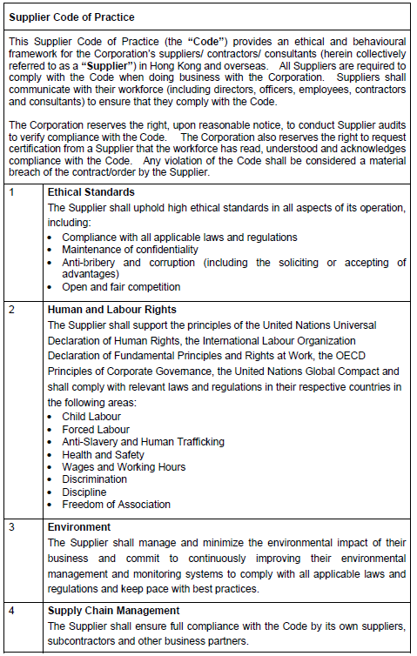

On behalf of the management and staff, I confirm full compliance with this Ethical Code of Conduct.

### (to be signed by the Chairman, CEO, Human Resources Director or

### a member of Senior Management)

|  |  |  |  |  |
| --- | --- | --- | --- | --- |
| Signature: |  |  | Date: |  |
| Name / Title: |  |  | Company: |  |
| And |  |  |  |  |
| Signature: |  |  | Date: |  |
| Name / Title: |  |  | Company: |  |