Background
MTR Corporation (“Corporation”) is going to acquire Managed Detection and Response Services (“MDR”) as defined in the Gartner Market Guide as services allowing organizations to add 24/7 dedicated threat monitoring, detection and response capabilities via a turnkey approach.

Network Architecture
The high-level network architecture of the Corporation IT network is as follows:

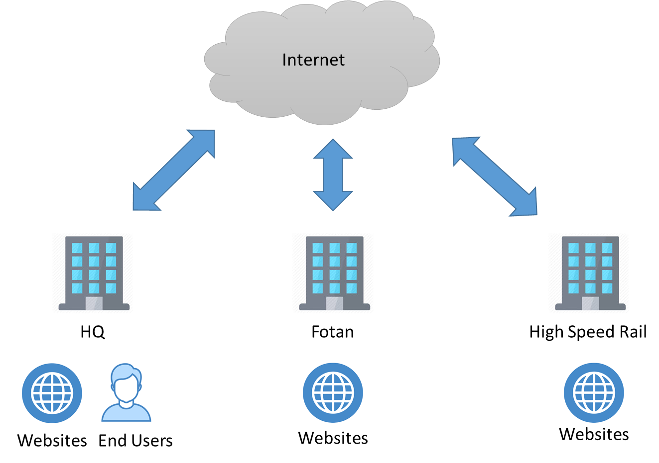
There are three Internet ingress/egress points. In headquarters, there are end users browsing the Internet. For all three ingress/egress points, there are websites accessed from Internet.
The MDR service provider is to provide a solution to cover about 12,000 endpoints (workstations and servers) and the 3 ingress/egress points.
Interested companies are required to submit the following information for prequalification assessment. Only qualified companies will be invited to tender.

Pre-qualification Questions for Suppliers Intending to provide MDR
Ref. | Question
1 | Please provide an overview of your MDR service offering.
2 | Do your MDR services cover both endpoints and network forensics?
3 | How many years have you provided MDR services for both endpoints and network?
4 | What are the service hours of MDR?
5 | Please provide the references with at least 100 MDR global customers and 2 MDR local customers references that have been using the supplier’s MDR services for at least 2 years.
6 | Please provide the customer reference(s) with at least 10 MDR customers with more than 10,000 endpoints.
7 | Does your MDR service cover both IT and OT environments? Please provide a customer reference.
8 | Please confirm that your MDR service can capture at least 10Gbps network throughput without packet loss.
9 | Do you provide a threat intelligence portal that harnesses machine, campaign, adversary and victim intelligence gained on the front lines of the world’s cyber attacks?
10 | Does your MDR service include regular proactive threat hunting at endpoints and networks for threats using latest intelligence? The frequency for threat hunting shall he at least monthly at both endpoint and network level.
11 | What are the required endpoint and network technology stacks for you to perform the MDR services?
12 | Please confirm that the time between identification of a high severity incident and submission of an investigation report to be 1 hour or less.
13 | Please confirm the time from the occurrence of an alert to the alert processed by the MDR services is 30 minutes or less.
14 | Do you have a dashboard and portal about the status, incidents, reports, intelligence and as a communication platform?
15 | Please confirm you have at least quarterly service review with your customer.
16 | Please provide a sample investigation report.
17 | Please confirm that a dedicated consultant will be assigned to follow up all technical issues related to the services.

