Prequalification Invitation Reference No, Q122299

Modernization and Migration of API Gateway

Prequalification Questionnaire for Prospective Contractors

General Instructions
The responses to the questions below by applicants for prequalification shall provide complete, true, accurate and up to date information required to enable the MTR Corporation Limited (the Corporation) to prequalify a company (the Applicant) to tender for the Contract as described in the Prequalification Questionnaire.

When completing this Prequalification Questionnaire, Applicants shall be aware of the following conditions:

- The Corporation shall treat all responses in this Prequalification Questionnaire as confidential and undertakes not to disclose the responses to others (with the exception of the Corporation's financial, legal and insurance advisors and the Government of Hong Kong Special Administrative Region, as appropriate, during the prequalification and the tender assessment period).

- Completion of the Prequalification Questionnaire shall not bind the Corporation to invite an Applicant to submit a tender and no reasons shall be given for the exclusion of unsuccessful Applicants.

- The composition of the list of tenderers shall rest entirely with the Corporation and its decisions shall be final.

- In the event that the applicant has or may have a conflict of interest which may affect its judgment in relation to the contract or its ability to properly discharge the works or services to be delivered (including dealings with third parties), then the applicant shall immediately notify the Corporation as to the nature of the conflict or potential conflict of interest and thereafter shall discuss and agree with the Corporation what action is necessary to resolve the conflict.

- The Applicant shall not, and shall ensure that its directors, employees, agents and subcontractors shall not, offer or give any advantage as defined in the Prevention of Bribery Ordinance (Cap. 201) to any employee or agent of MTRCL. Any breach of or non-compliance of this condition by the Applicant shall, without affecting its liability for such breach or non-compliance, result in its application not being considered.

Prequalification Questions
- Please provide your company profile including the organization structure, Business Registration (BR), technical support team capabilities and clients list.

Company Name:
Correspondence Address:
Year of Company Establishment:
Business Nature: | - System development  - System integration and implementation  - IT Consultancy  - Business Process Consultancy  - Others: ____________________________
Contact Person:
Telephone No.:
Email Address:
Web Site:

- Please confirm whether your company is product owner of the API management platform, or an approved reseller of the platform.

- Please provide at least three (3) API management platform project job references that were implemented within the last five (5) years.
The following information of the job reference shall be provided.
- the client name, contact person and telephone number
- the year of implementation
- Contract value
- the description and scope of service

- Please confirm your compliant on providing local technical support for API management platform in Hong Kong and provide the technical support team structure.

- Please advise the migration approach to migrate the existing API functions to the proposed platform.

- Please provide the preliminary quotation (including Implement service and annual licenses/ subscription cost) for our consideration.

Supplier Code of Practice
Applicant is required to comply with the Corporation’s Supplier Code of Conduct. This provides an ethical and behavioural framework for contractor doing business with the Corporation.
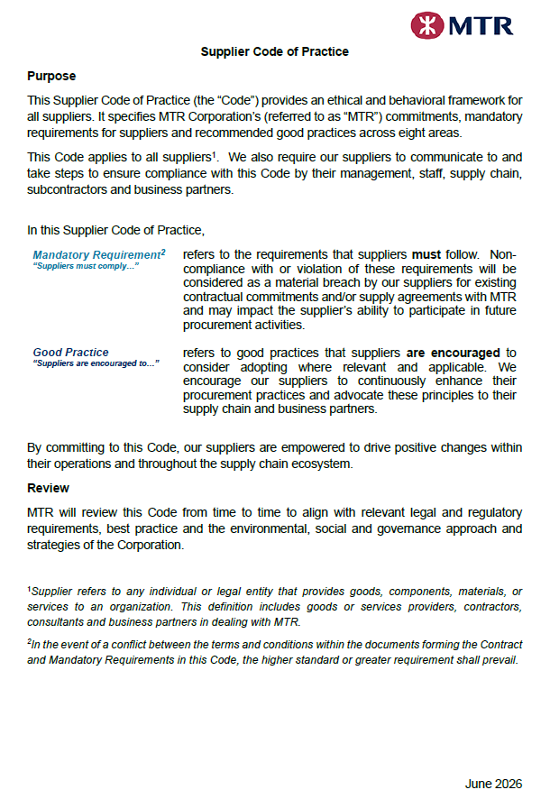
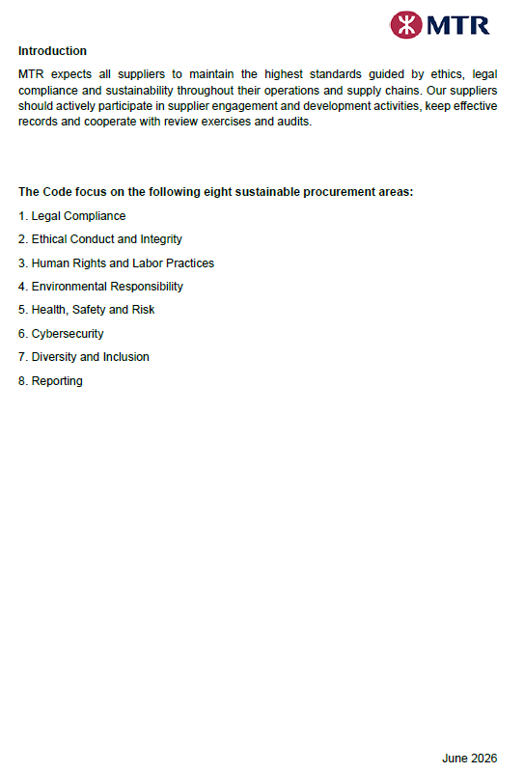
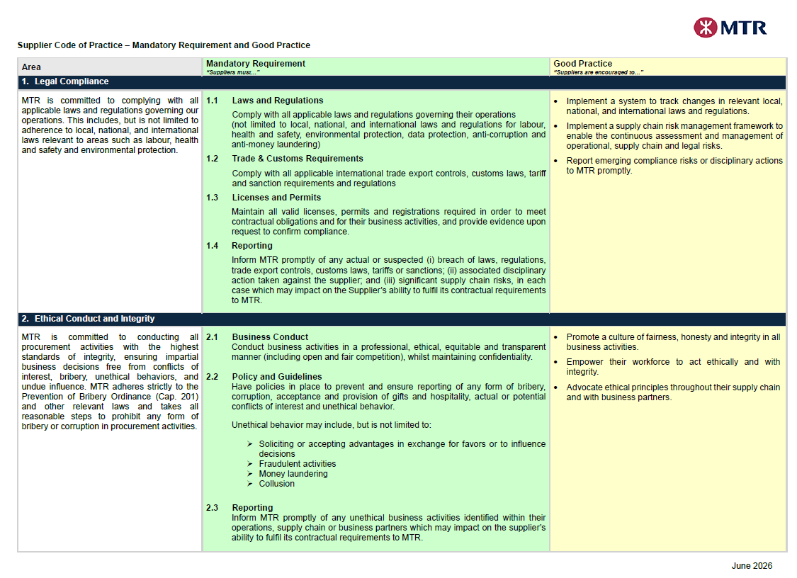
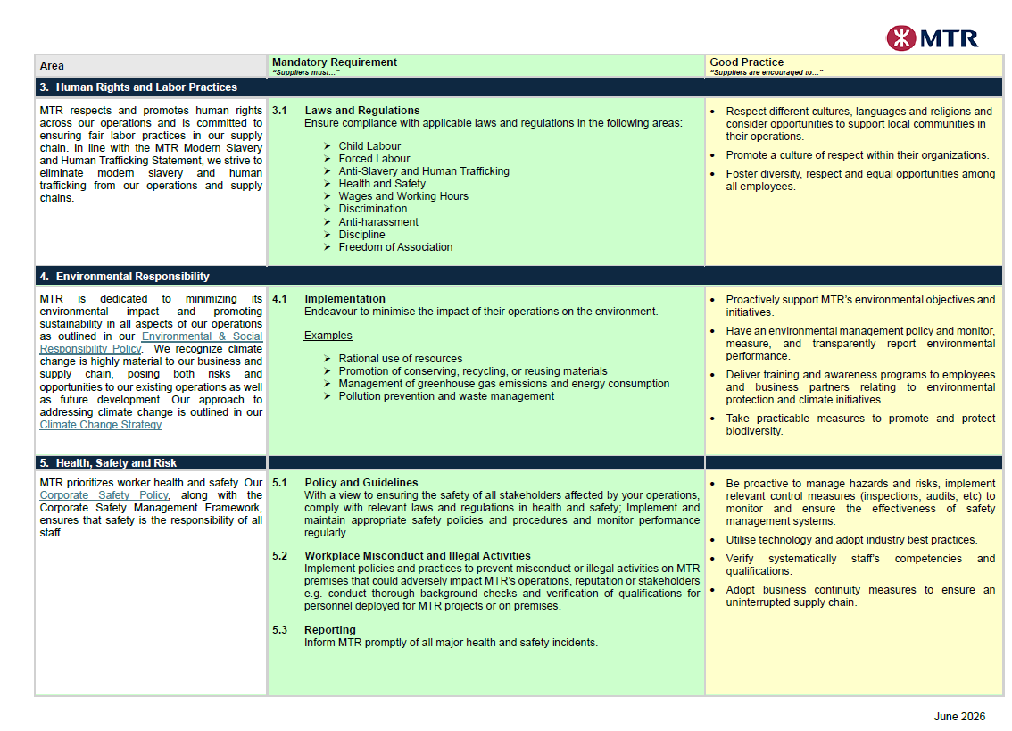
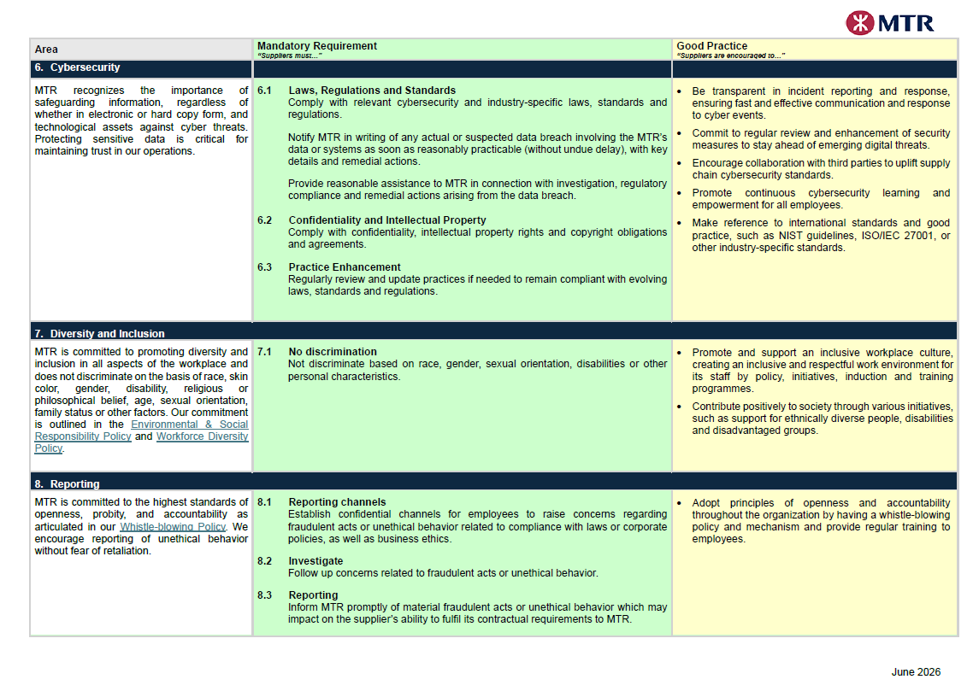
On behalf of the management and staff, I confirm full compliance with this Supplier Code of Conduct.

(to be signed by the Chairman, CEO, Human Resources Director or a member of Senior Management)

Signature: |  |  | Date:
Name / Title: |  |  | Company:

