Prequalification Questionnaire for Prospective Contractors

General Instructions
The responses to Section 1 to 4 below by applicants for prequalification shall provide complete, true, accurate and up to date information required to enable the MTR Corporation Limited (the Corporation) to prequalify a company (the Applicant) to tender for the Contract(s) as described in the Prequalification Questionnaire.

When completing this Prequalification Questionnaire, Applicants shall be aware of the following conditions:

- The Corporation shall treat all responses in this Prequalification Questionnaire as confidential and undertakes not to disclose the responses to others (with the exception of the Corporation's financial, legal and insurance advisors and the Government of Hong Kong Special Administrative Region, as appropriate, during the prequalification and the tender assessment period).

- Completion of the Prequalification Questionnaire shall not bind the Corporation to invite an Applicant to submit a tender and no reasons shall be given for the exclusion of unsuccessful Applicants.

- The composition of the list of tenderers shall rest entirely with the Corporation and its decisions shall be final.

- In the event that the applicant has or may have a conflict of interest which may affect its judgment in relation to the contract or its ability to properly discharge the works or services to be delivered (including dealings with third parties), then the applicant shall immediately notify the Corporation as to the nature of the conflict or potential conflict of interest and thereafter shall discuss and agree with the Corporation what action is necessary to resolve the conflict.

- The Applicant shall not, and shall ensure that its directors, employees, agents and subcontractors shall not, offer or give any advantage as defined in the Prevention of Bribery Ordinance (Cap. 201) to any employee or agent of the Corporation. Any breach of or non-compliance of this condition by the Applicant shall, without affecting its liability for such breach or non-compliance, result in its application not being considered.

Applicant shall note the following:-

- Please fill in all cells highlighted in yellow.
- For Section 3
  - Please submit job reference and clients’ commendation (if any) in Appendix with the Item No.
  - Please insert additional table in same format for more job reference when necessary.

Submitted by
Company name:

Contact person:

Telephone No.:

Email address:

Date:

Section 1
Company Profile
Year of company establishment | Established in ___________  Copy of business and company registration is enclosed.
Organization chart | Submitted in the form of Appendix by referring to Section No. 1
Annual business turnover in Hong Kong Market | HK$ (per year)
Annual business turnover worldwide | HK$ (per year)
Annual business turnover in MTRCL | HK$ (per year)
Submission of latest annual report and audited accounts for the preceding three financial years | Yes / No  Submitted for Year ____________________

Section 2
Item A | Manpower (Local support staff) | Your Company | Your Contractor
1 | No. of Project Management Staff
Item B | Manpower (Software staff) | Your Company | Your Contractor
1 | No. of Software Manager
2 | No. of Software Development Staff
Item C | Manpower  (Installation and support staff) | Your Company | Your Contractor
1 | No. of Site Supervisor
2 | No. of Installation Staff
3 | No. of Technical Support Staff
4 | Please confirm whether your software and technical support team is able to provide on‑site support, upon request, throughout the contract period, including the DLP and maintenance period. | Yes / No (If “No”, please specify details.) | Yes / No (If “No”, please specify details.)

Section 3
Item A | Job reference(s) (from you or your contractor) for project(s) involving customer-facing hardware installation in MTR stations. Please provide at least two local job references within the past three years.
1 | Project name
 | Contract no.
 | Scope of works
2 | Project name
2 | Contract no.
2 | Scope of works

Item B | Job reference(s) (from you or your contractor) for Virtual Assistant Kiosk project(s) deployed on‑premises as customer‑facing public self‑service kiosks in Hong Kong. Please provide at least one job reference for local clients within the past three years.
1 | Client’s name with contact person
 | Contract description (type of service provided)
 | No. of VAK deployed under the Contract
 | VAK service period

Item C | Job reference(s) (from you or your contractor) for AI-powered and voice-controlled self-service kiosk project(s), utilizing a “Hyper realistic Virtual Human” for user interaction, deployed as customer-facing to the public in Hong Kong. Please provide at least one job reference within the past three years.
1 | Client’s name with contact person
 | Contract description (type of service provided)
 | No. of users

Item D | Job reference(s) (from you or your contractor) for project(s) having interface with Call Centre and mobile phone platform. Please provide at least one job reference within the past three years.
1 | Client’s name with contact person
 | Contract description (type of service provided)
 | Video / Voice call service

Item E | Job reference(s) (from you or your contractor) for project(s) that include a video demonstration of the VA system deployed in an actual transportation, government, or similar environment, demonstrating its interactive capabilities and the ability to remotely control the system, including audio adjustment. Please provide at least one job reference within the past three years.
1 | Client’s name with contact person
 | Contract description (type of service provided)
 | Video Demonstration

Item F | Job reference(s) for project(s) of a similar scale that demonstrate the ability to deploy the solution at a rate of 10 stations per half-year.
1 | Client’s name with contact person
 | Contract description (type of service provided)
 | No. of stations deployed per half-year

Item G | Job reference(s) for project(s) of a similar nature in an actual transportation, government, or similar environment, involving migration services from cloud platform to on-premises solution.
1 | Client’s name with contact person
 | Contract description (type of service provided)

(Please insert page and table beyond this page for more job reference when necessary)

Section 4
Supplier Code of Practice
Applicant is required to comply with the Corporation’s Supplier Code of Conduct. This provides an ethical and behavioural framework for contractor doing business with the Corporation.
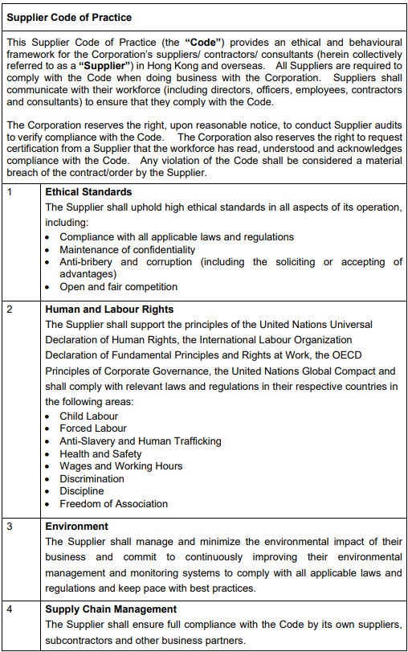

On behalf of the management and staff, I confirm full compliance with this Supplier Code of Conduct.

(to be signed by the Chairman, CEO, Human Resources Director or a member of Senior Management)

Signature: |  |  | Date:
Name / Title: |  |  | Company:
And
Signature: |  |  | Date:
Name / Title: |  |  | Company:

