**Prequalification Questionnaire for Prospective Contractors**

**General Instructions**

The responses to Section 1 to 3 below by applicants for prequalificationshall provide complete, true, accurate and up to date information required to enable the MTR Corporation Limited (the Corporation) to prequalify a company (the Applicant) to tender for the Contract(s) as described in the Prequalification Questionnaire.

When completing this Prequalification Questionnaire, Applicants shall be aware of the following conditions:

1. The Corporation shall treat all responses in this Prequalification Questionnaire as confidential and undertakes not to disclose the responses to others (with the exception of the Corporation's financial, legal and insurance advisors and the Government of Hong Kong Special Administrative Region, as appropriate, during the prequalification and the tender assessment period).
2. Completion of the Prequalification Questionnaire shall not bind the Corporation to invite an Applicant to submit a tender and no reasons shall be given for the exclusion of unsuccessful Applicants.
3. The composition of the list of tenderers shall rest entirely with the Corporation and its decisions shall be final.
4. In the event that the applicant has or may have a conflict of interest which may affect its judgment in relation to the contract or its ability to properly discharge the works or services to be delivered (including dealings with third parties), then the applicant shall immediately notify the Corporation as to the nature of the conflict or potential conflict of interest and thereafter shall discuss and agree with the Corporation what action is necessary to resolve the conflict.
5. The Applicant shall not, and shall ensure that its directors, employees, agents and subcontractors shall not, offer or give any advantage as defined in the Prevention of Bribery Ordinance (Cap. 201) to any employee or agent of the Corporation. Any breach of or non-compliance of this condition by the Applicant shall, without affecting its liability for such breach or non-compliance, result in its application not being considered.

Applicant shall note the following:-

1. Please fill in all cells highlighted in yellow.
2. For Section 2
   1. Please submit job reference and clients’ commendation (if any) in Appendix with the Item No.
   2. Please insert additional table in same format for more job reference when necessary.

**Submitted by**

|  |  |
| --- | --- |
| **Company name:** |  |
| **Contact person:** |  |
| **Telephone No.:** |  |
| **Email address:** |  |
| **Date:** |  |

**Section 1**

|  |  |  |
| --- | --- | --- |
| **Company Profile** | | |
| **Package A – Office Workstation and Accessories – Custom Made Type** *(Please refer to Appendix 1 for details)* | | |
| The Supplier is interested in this Package A | *Yes / No | |
| The Supplier is able to supply ALL items according to Appendix 1. | *Yes / No | If “No”, please specify |
| Please provide the details of the factory for manufacturing the office workstation. | Location: | |
| Area Covered: sq.m. | |
| Please provide the normal delivery leadtime: |  | |
| Order for 10 workstations or below : |  | |
| Order for more than 10 workstations : |  | |
| The Supplier shall warrant each element of the workstation against manufacturing defects for a minimum of Five (5) years. | *Yes / No | If “No”, please specify |
| The Supplier shall ensure the availability of replacement parts for a minimum of Five (5) years after installation. | *Yes / No | If “No”, please specify |
| **Package B – Office Workstation and Loose Furniture - Open Plan Office Type** *(Please refer to Appendix 2 for details)* | | |
| The Supplier is interested in this Package B | *Yes / No | |
| The Supplier is able to supply ALL items according to Appendix 2. | *Yes / No | If “No”, please specify |
| Please provide the details of the factory for manufacturing the office workstation. | Location: | |
| Area Covered: sq.m. | |
| Please provide the normal delivery leadtime: |  | |
| Order for 10 workstations or below : |  | |
| Order for more than 10 workstations : |  | |
| Order for loose furniture : |  | |
| The Supplier shall warrant each element of the workstation against manufacturing defects for a minimum of Five (5) years. | *Yes / No | If “No”, please specify |
| The Supplier shall ensure the availability of replacement parts for a minimum of Five (5) years after installation. | *Yes / No | If “No”, please specify |

**Section 2**

**Job Reference -** Please provide at least THREE (3) job references for supply of similar tailor-made office workstations in past three (3) years with Contract Sum over HK$300,000 per order / per annual.

| **Package A – Office Workstation and Accessories – Custom Made Type** | | |
| --- | --- | --- |
| 1 | Customer Name |  |
|  | Contact Person |  |
|  | E-mail Address |  |
|  | Tel No. |  |
|  | Description/ Types of item supplied |  |
|  | Contract Sum (HK$) |  |
|  | Submission of Photos / catalogue of the custom-made furniture | *Yes / No |
| 2 | Customer Name |  |
|  | Contact Person |  |
|  | E-mail Address |  |
|  | Tel No. |  |
|  | Description/ Types of item supplied |  |
|  | Contract Sum (HK$) |  |
|  | Submission of Photos / catalogue of the custom-made furniture | *Yes / No |

| 3 | Customer Name |  |
| --- | --- | --- |
|  | Contact Person |  |
|  | E-mail Address |  |
|  | Tel No. |  |
|  | Description/ Types of item supplied |  |
|  | Contract Sum (HK$) |  |
|  | Submission of Photos / catalogue of the custom-made furniture | *Yes / No |
| 4 | Customer Name |  |
|  | Contact Person |  |
|  | E-mail Address |  |
|  | Tel No. |  |
|  | Description/ Types of item supplied |  |
|  | Contract Sum (HK$) |  |
|  | Submission of Photos / catalogue of the custom-made furniture | *Yes / No |

**Section 2**

| **Package B – Office Workstation and Loose Furniture - Open Plan Office Type** | | |
| --- | --- | --- |
| 1 | Customer Name |  |
|  | Contact Person |  |
|  | E-mail Address |  |
|  | Tel No. |  |
|  | Description/ Types of item supplied |  |
|  | Contract Sum (HK$) |  |
|  | Submission of Photos / catalogue of the open plan furniture | *Yes / No |
| 2 | Customer Name |  |
|  | Contact Person |  |
|  | E-mail Address |  |
|  | Tel No. |  |
|  | Description/ Types of item supplied |  |
|  | Contract Sum (HK$) |  |
|  | Submission of Photos / catalogue of the open plan furniture | *Yes / No |

**Section 2**

| 3 | Customer Name |  |
| --- | --- | --- |
|  | Contact Person |  |
|  | E-mail Address |  |
|  | Tel No. |  |
|  | Description/ Types of item supplied |  |
|  | Contract Sum (HK$) |  |
|  | Submission of Photos / catalogue of the open plan furniture | *Yes / No |
| 4 | Customer Name |  |
|  | Contact Person |  |
|  | E-mail Address |  |
|  | Tel No. |  |
|  | Description/ Types of item supplied |  |
|  | Contract Sum (HK$) |  |
|  | Submission of Photos / catalogue of the open plan furniture | *Yes / No |

* Please delete where inappropriate

***(Please insert page and table beyond this page for more job reference when necessary)***

**Section 3**

**Supplier Code of Practice**

Applicant is required to comply with the Corporation’s Supplier Code of Conduct.  This provides an ethical and behavioural framework for contractor doing business with the Corporation. 

On behalf of the management and staff, I confirm full compliance with this Ethical Code of Conduct.

### (to be signed by the Chairman, CEO, Human Resources Director or a member of Senior Management)

|  |  |  |  |  |
| --- | --- | --- | --- | --- |
| Signature: |  |  | Date: |  |
| Name / Title: |  |  | Company: |  |
| And |  |  |  |  |
| Signature: |  |  | Date: |  |
| Name / Title: |  |  | Company: |  |

**Appendix 1 – Drawings of Tailor-made WorkstationsDiagram, engineering drawing

Description generated with very high confidence**

**Diagram, engineering drawing

Description generated with very high confidence**

**Diagram, engineering drawing

Description generated with very high confidence**

**Diagram, engineering drawing

Description generated with very high confidence**

**Diagram, engineering drawing

Description generated with very high confidence**

**Diagram, engineering drawing

Description generated with very high confidence**

**Diagram, engineering drawing

Description generated with very high confidence**

**Diagram, engineering drawing

Description generated with very high confidence**

**Diagram, engineering drawing

Description generated with very high confidence**

**Diagram, engineering drawing

Description generated with very high confidence**

**Diagram

Description generated with very high confidence**

**Diagram, engineering drawing

Description generated with very high confidence**

**Diagram, engineering drawing

Description generated with very high confidence**

**Diagram, engineering drawing

Description generated with very high confidence**

**Table top with both side laminated & round edge**

🡪 Thickness: 32mm

🡪 Color: Grey

🡪 Reference Photos:

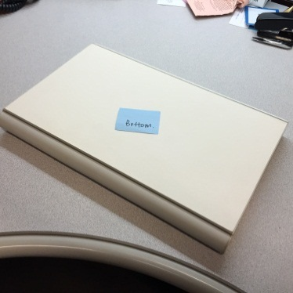

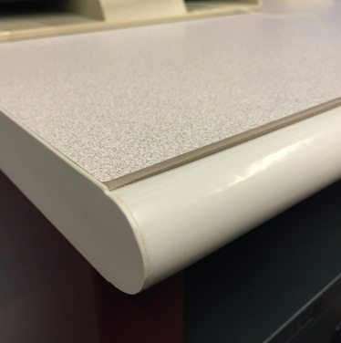

**actual worktop**

**Screen with PVC edging**

🡪 Thickness: 25mm

🡪 Color: Grey (fabric upholstery) and Dark Grey (PVC edging)

🡪 One-sided tackable

🡪 Reference Photos:

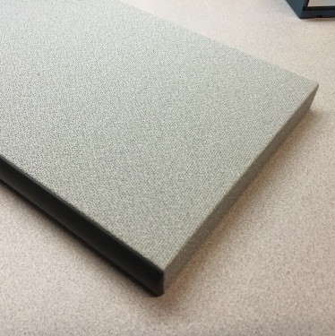

**sample board reference**

**Partition with frame**

🡪 Thickness: 50mm

🡪 Color: Grey (fabric upholstery) and Burgendy (frame)

🡪 Reference Photos:

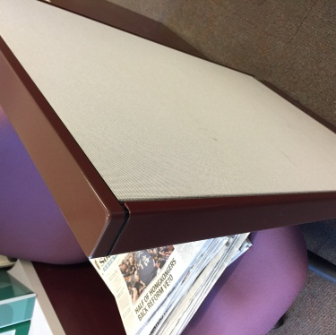

**actual partition**

**Appendix 2 – Drawings/ Photos for Office Workstations for Open Plan Office**

1. 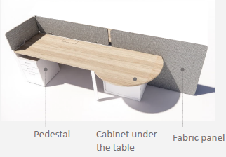**Manager Workstation (i)**
2. **Manager Workstation (ii)**

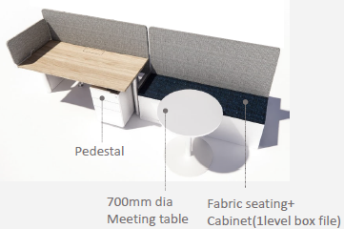

1. **General Staff Workstation**



1. **Loose Furniture**
   1. **Round Meeting Table (MFC table top/ Metal base)**



* 1. **Square Meeting Table (MFC table top/ Metal base)**

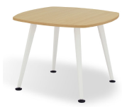

* 1. **Coffee Table (MFC table top/ Metal base)**

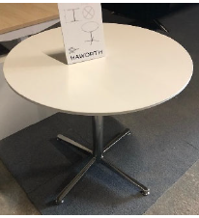

* 1. **High Swing Door Cabinet with Closet and Individual Lock (Metal with power coated)**

