Prequalification Questionnaire for Prospective Contractors

General Instructions
The responses to Section 1 to 3 below by applicants for prequalification shall provide complete, true, accurate and up to date information required to enable the MTR Corporation Limited (the Corporation) to prequalify a company (the Applicant) to tender for the Contract(s) as described in the Prequalification Questionnaire.

When completing this Prequalification Questionnaire, Applicants shall be aware of the following conditions:

- The Corporation shall treat all responses in this Prequalification Questionnaire as confidential and undertakes not to disclose the responses to others (with the exception of the Corporation's financial, legal and insurance advisors and the Government of Hong Kong Special Administrative Region, as appropriate, during the prequalification and the tender assessment period).

- Completion of the Prequalification Questionnaire shall not bind the Corporation to invite an Applicant to submit a tender and no reasons shall be given for the exclusion of unsuccessful Applicants.

- The composition of the list of tenderers shall rest entirely with the Corporation and its decisions shall be final.

- In the event that the applicant has or may have a conflict of interest which may affect its judgment in relation to the contract or its ability to properly discharge the works or services to be delivered (including dealings with third parties), then the applicant shall immediately notify the Corporation as to the nature of the conflict or potential conflict of interest and thereafter shall discuss and agree with the Corporation what action is necessary to resolve the conflict.

- The Applicant shall not, and shall ensure that its directors, employees, agents and subcontractors shall not, offer or give any advantage as defined in the Prevention of Bribery Ordinance (Cap. 201) to any employee or agent of the Corporation. Any breach of or non-compliance of this condition by the Applicant shall, without affecting its liability for such breach or non-compliance, result in its application not being considered.

Applicant shall note the following:-

- Please fill in all cells highlighted in yellow.
- For Section 2
  - Please submit job reference and clients’ commendation (if any) in Appendix with the Item No.
  - Please insert additional table in same format for more job reference when necessary.

Submitted by
Company name:

Contact person:

Telephone No.:

Email address:

Date:

Introduction

- The Contractor is responsible for the provision of dismantle, installation and inventory & logistic management service for system furniture to MTR Corporation Limited (the Employer) at fixed prices on as-and-when-required basis.

- Summary of the Services as listed below shall not be construed as exhaustive; the Contractor shall provide all necessary works, labour and transport for completion of the Services:

  - To dismantle and install; reconfigure and relocate various types and brands of furniture, including:
    - General System Furniture including Work Benches & Workstations
    - Mobile Compactus Storage System
    - Demountable Partition

  - Inventory & Logistic Management Services
    - Storage service for furniture
    - Stock taking and furniture in/ out service

- The duration of this Contract is three (3) years from 01-Jan-2024 to 31-Dec-2026, with option to renew for another term of 3-year Contract at the discretion of the Employer.

Section 1 – Compliance

Note: System Furniture including Work Bench, Panel, Column Mounted Shelf, Lateral Filing Cabinet, Overhead Cabinet, Overhead Shelf, Tasklight, Keyboard Shelf, Fixed Pedestal, Counter Top and Round Table

Item | Description | To be completed by supplier
(I) | Furniture Relocation Services  The Contractor shall provide all the required tools, equipment and manpower to dismantle, transport and re-install the system furniture, compactus and demountable partition upon the Employer’s request on as-and-when-required basis.  ** Please tick the box below (yes / no) to indicate whether your company has previous experience in dismantling and reinstalling the following system furniture:-
1) | System Furniture
a | "Steelcase" System Furniture (Refer to Appendix - Photo 1, 2, 3 and 4) | ☐Yes ☐ No
b | "Lamex" Open Plan Workstation (Refer to Appendix - Photo 5 and 6) | ☐Yes ☐ No
c | "Chung Wah" System Furniture (Refer to Appendix - Photo 7, 8, 9, 10) | ☐Yes ☐ No
d | Other System Furniture (Refer to Appendix - Photo 11, 12, 13) | ☐Yes ☐ No
2) | Compactus
a | "Kongol" Compactus (Refer to Appendix - Photo 14, 15) | ☐Yes ☐ No
3) | Demountable Partition
a | "JEB" Demountable Partition (Refer to Appendix - Photo 16, 17) | ☐Yes ☐ No
b | "EPG" Demountable Partition (Refer to Appendix - Photo 18, 19) | ☐Yes ☐ No
c | "Clestra" Demountable Partition (Refer to Appendix - Photo 20, 21) | ☐Yes ☐ No
(II) | Furniture Storage and Management Service  The Contractor shall provide a 24-hour open warehouse with around 12,000 sq.ft. lock-up space exclusively for the Employee during the 2-year contract period for:-  - A short term storage service for the furniture during office refurbishment projects  - A long term storage service for re-usable furniture  The Contractor shall also provide furniture management services including stock taking and furniture in/ out service upon request  ** Please tick the appropriate box and provide information below:-
1) | Warehouse Information
a | - Type of warehouse (Self-owned / Rental) | ☐Self-owned  ☐Rental
b | - Location
c | - Total floor area | Sq.ft
d | - Open 24 hours for furniture in and out | ☐Yes ☐ No
e | - The warehouse is readily available (Please state lead time if "No") | ☐Yes ☐ No
2) | The Contractor shall provide furniture stock taking and management service | ☐Yes ☐ No
(III) | Estimated Lead Time Required for Dismantling and Re-installation of Workstation in Photo 4 | mins
(IV) | Manpower and Logistic Capability
1 | Nos. of labour which can be deployed under this contract | Mover nos.
1 | Nos. of labour which can be deployed under this contract | Technician nos.
1 | Nos. of labour which can be deployed under this contract | Site Supervisor/ Leader nos.
1 | Nos. of labour which can be deployed under this contract | Driver nos.
2 | Nos. of vehicles which can be deployed under this contract | ☐5.5 Ton nos.
2 | Nos. of vehicles which can be deployed under this contract | ☐9 Ton nos.
2 | Nos. of vehicles which can be deployed under this contract | ☐Others Ton nos.
2 | Nos. of vehicles which can be deployed under this contract | Ton nos.
(V) | Response Lead Time for Furniture Relocation Service
1 | For normal cases, service can be provided with 7 days prior notice | ☐Yes ☐ No Days
2 | For urgent cases, service can be provided with 2 days prior notice | ☐Yes ☐ No Days
** Please " √ "where appropriate

Section 2 – Job Reference

The Contractor shall provide at least Three (3) job references information with annual contract sum over HK$500,000 for each contract within the past 3 years for the providing furniture relocation and management services.

i. | Company Name
 | Contact Person
 | Tel No.
 | Email.
 | Annual Contract Sum:
 | Job Description:
 | Reference Letter enclosed?
ii. | Company Name
 | Contact Person
 | Tel No.
 | Email.
 | Annual Contract Sum:
 | Job Description:
 | Reference Letter enclosed?
iii. | Company Name
 | Contact Person
 | Tel No.
 | Email.
 | Annual Contract Sum:
 | Job Description:
 | Reference Letter enclosed?
Appendix 1 to Prequalification
Steelcase System Furniture
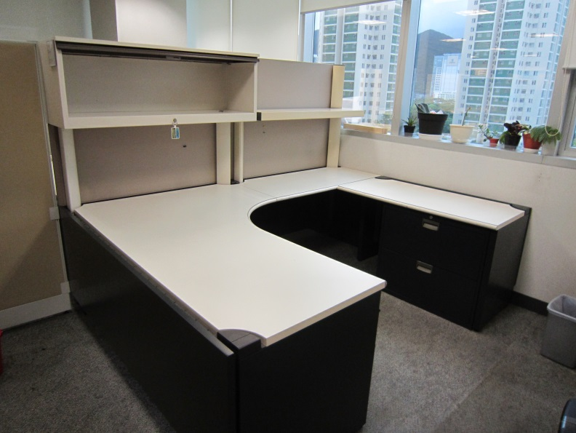  Photo 1 | 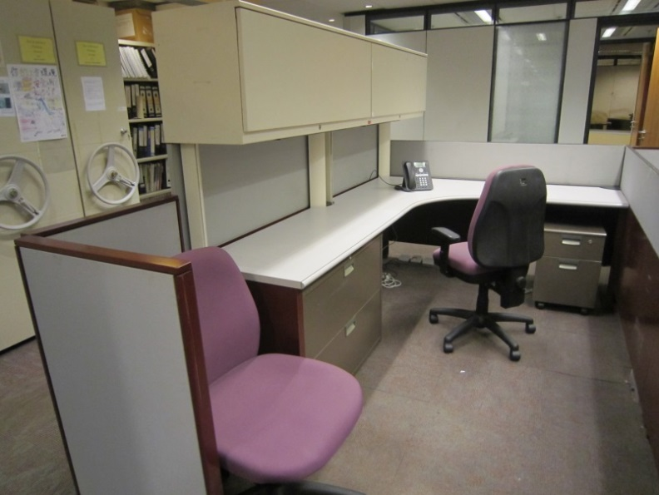  Photo 2
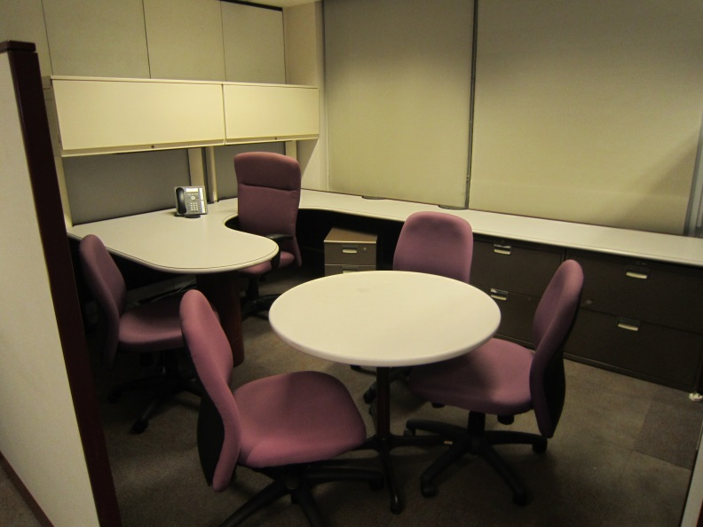  Photo 3 |   Photo 4
Lamex Open Plan Workstation
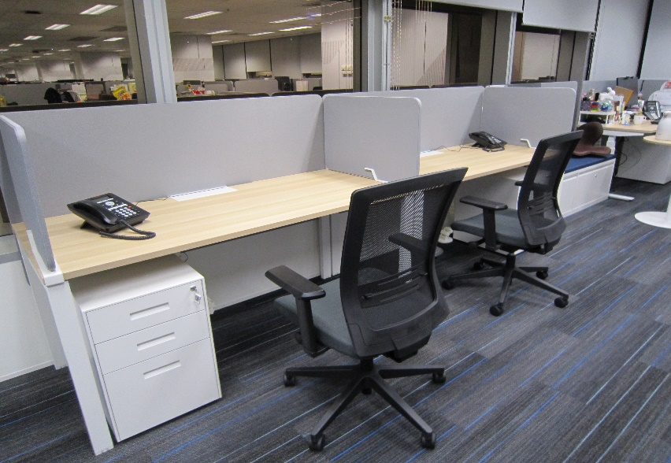  Photo 5 | 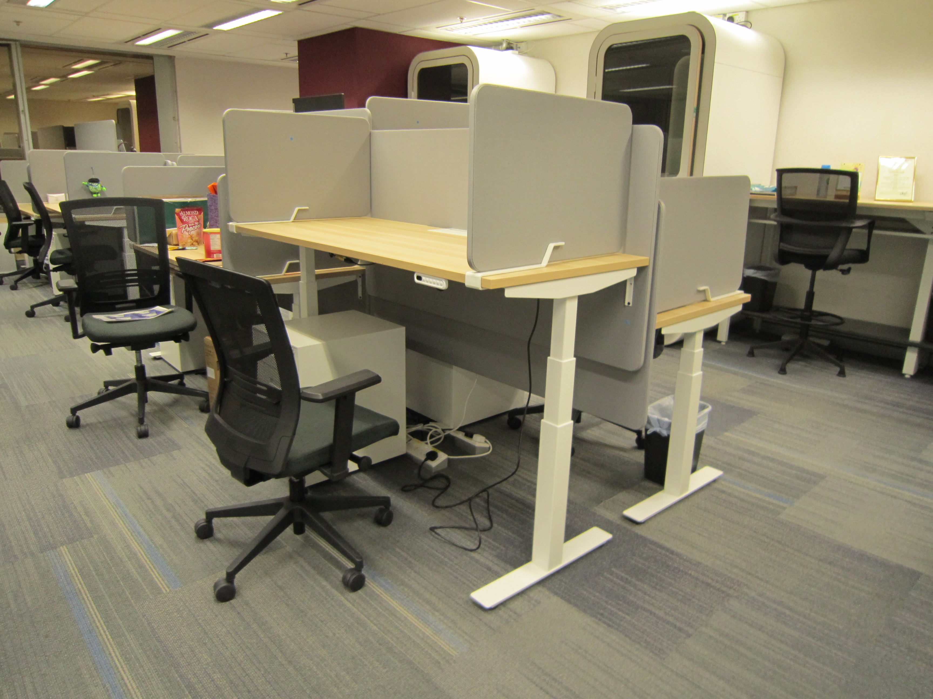  Photo 6

Chung Wah System Furniture
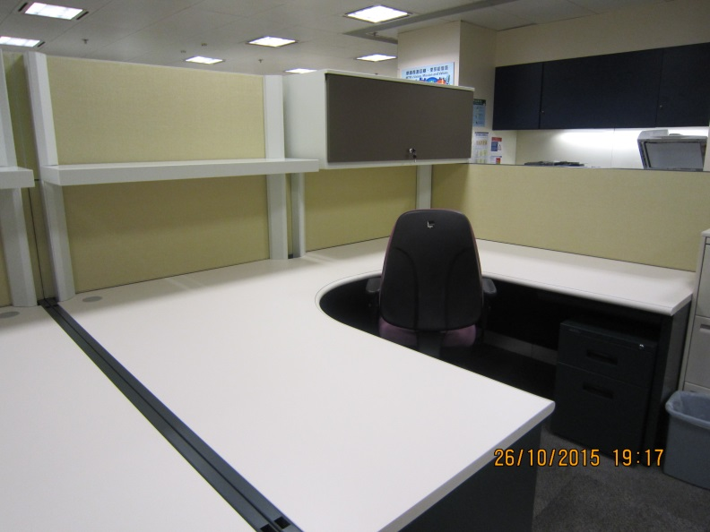  Photo 7 | 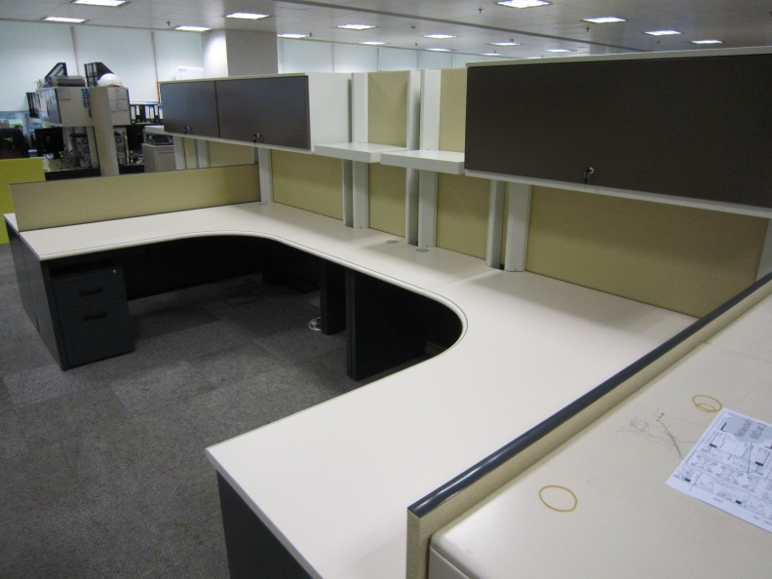  Photo 8
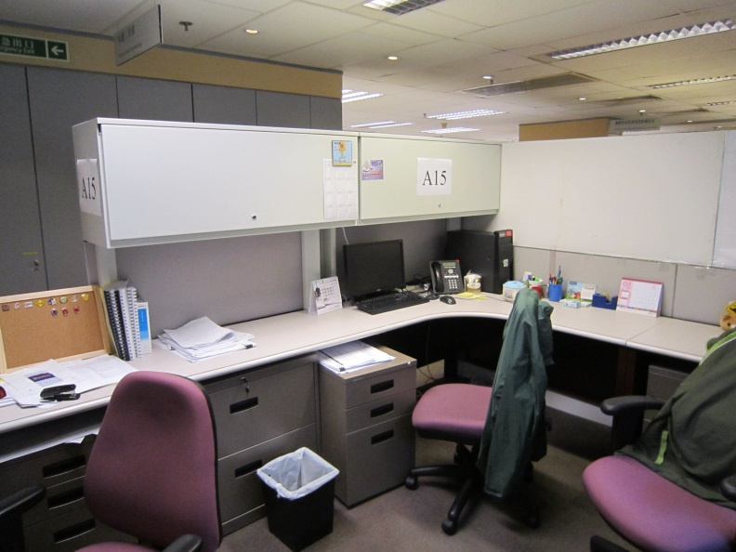  Photo 9 | 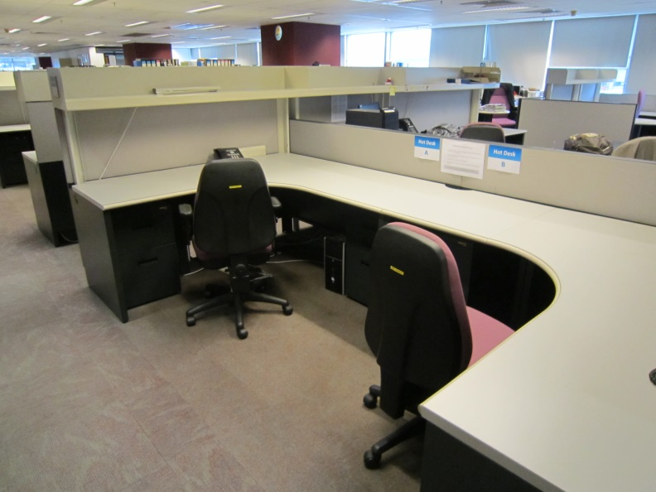  Photo 10
Other System Furniture
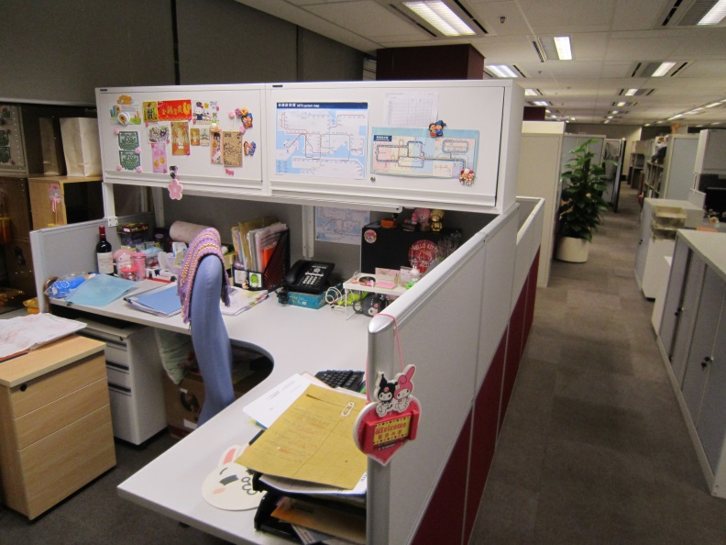  Photo 11 |   Photo 12
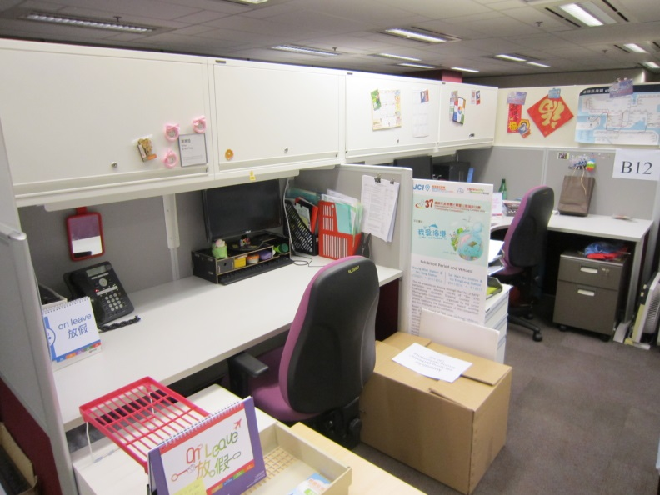
Photo 13
Kongol Compactus

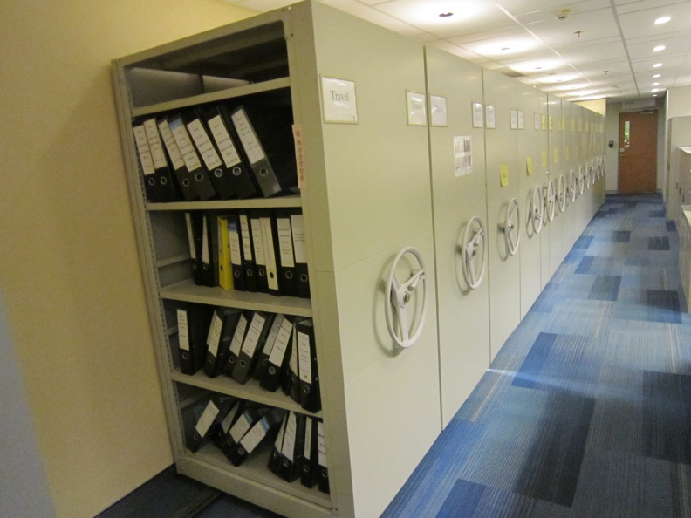  Photo 14 | 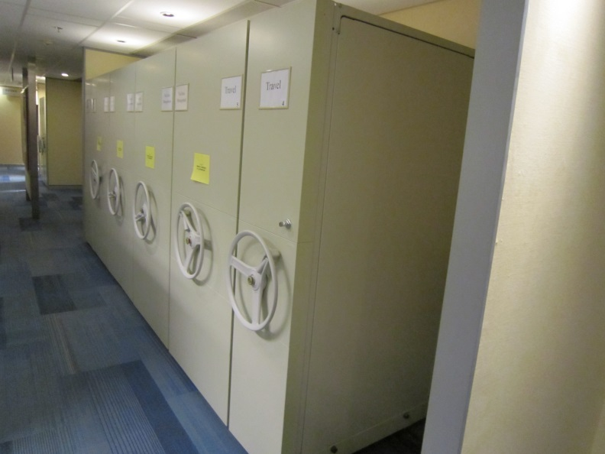  Photo 15
JEB Demountable Partition
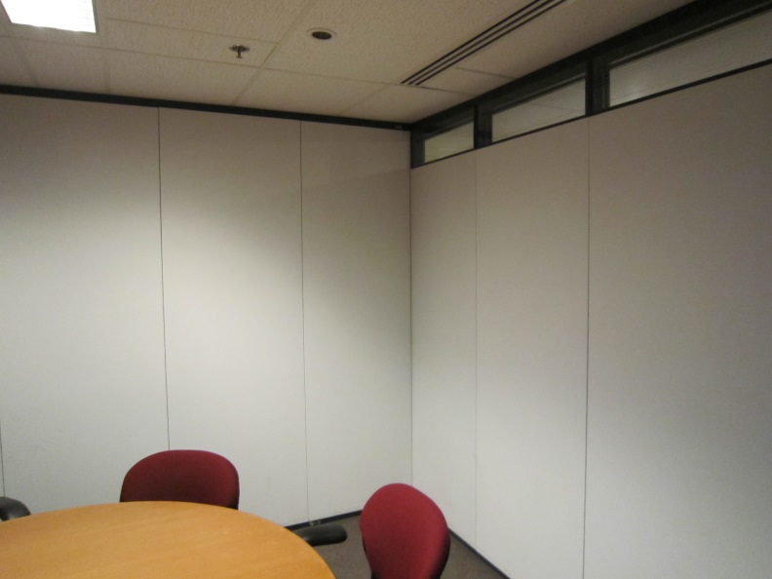  Photo 16 | 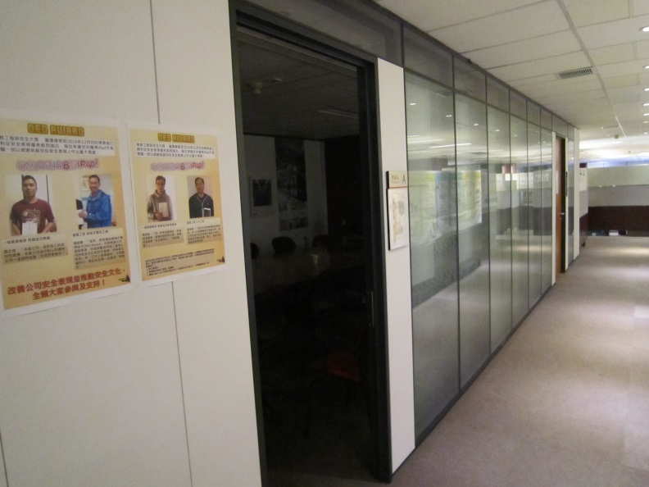  Photo 17
EPG Demountable Partition
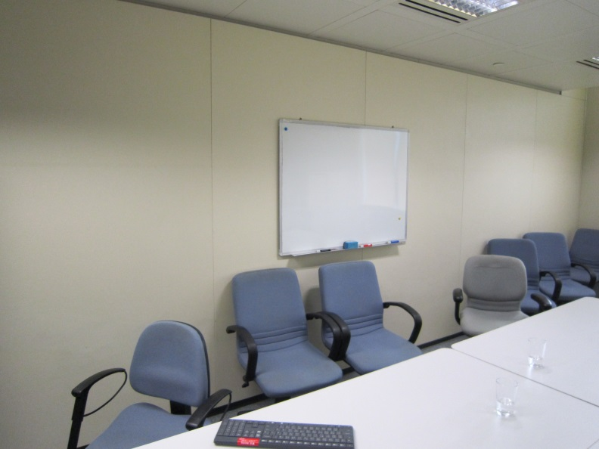  Photo 18 | 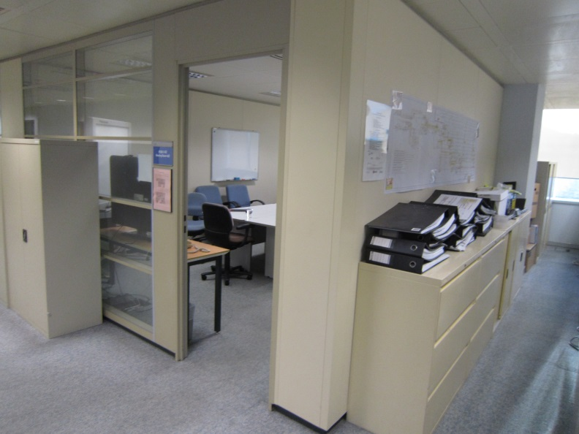  Photo 19
Clestra Demountable Partition
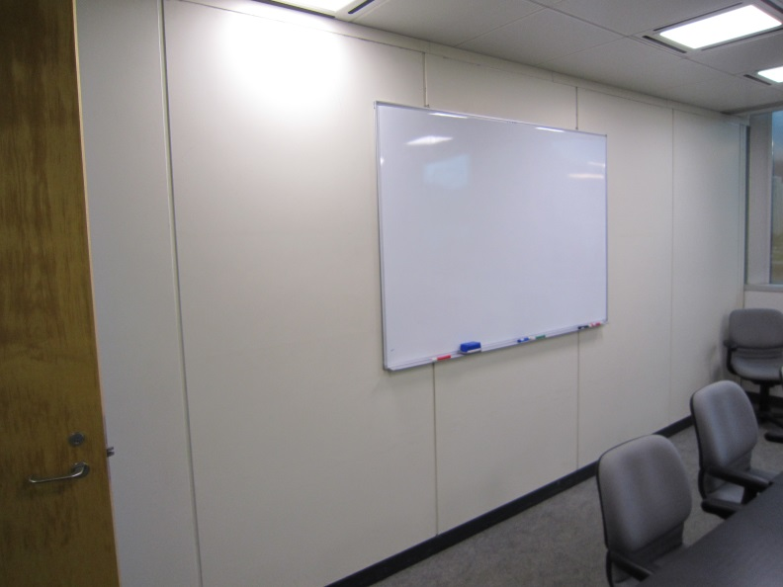  Photo 20 | 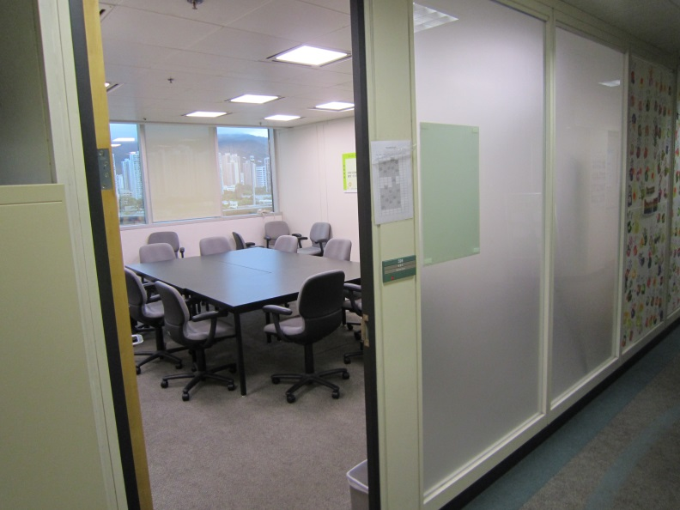  Photo 21

Section 3
Supplier Code of Practice
Applicant is required to comply with the Corporation’s Supplier Code of Conduct. This provides an ethical and behavioural framework for contractor doing business with the Corporation.
Supplier Code of Practice
This Supplier Code of Practice (the “Code”) provides an ethical and behavioural framework for the Corporation’s suppliers/ contractors/ consultants (herein collectively referred to as a “Supplier”) in Hong Kong and overseas. All Suppliers are required to comply with the Code when doing business with the Corporation. Suppliers shall communicate with their workforce (including directors, officers, employees, contractors and consultants) to ensure that they comply with the Code.
The Corporation reserves the right, upon reasonable notice, to conduct Supplier audits to verify compliance with the Code. The Corporation also reserves the right to request certification from a Supplier that the workforce has read, understood and acknowledges compliance with the Code. Any violation of the Code shall be considered a material breach of the contract/order by the Supplier.
1 | Ethical Standards  The Supplier shall uphold high ethical standards in all aspects of its operation, including:  - Compliance with all applicable laws and regulations  - Maintenance of confidentiality  - Anti-bribery and corruption (including the soliciting or accepting of advantages)  - Open and fair competition
2 | Human and Labour Rights  The Supplier shall support the principles of the United Nations Universal Declaration of Human Rights, the International Labour Organization Declaration of Fundamental Principles and Rights at Work, the OECD Principles of Corporate Governance, the United Nations Global Compact and shall comply with relevant laws and regulations in their respective countries in the following areas:  - Child Labour  - Forced Labour  - Anti-Slavery and Human Trafficking  - Health and Safety  - Wages and Working Hours  - Discrimination  - Discipline  - Freedom of Association
3 | Environment  The Supplier shall manage and minimize the environmental impact of their business and commit to continuously improving their environmental management and monitoring systems to comply with all applicable laws and regulations and keep pace with best practices.
4 | Supply Chain Management  The Supplier shall ensure full compliance with the Code by its own suppliers, subcontractors and other business partners.

On behalf of the management and staff, I confirm full compliance with this Ethical Code of Conduct.

(to be signed by the Chairman, CEO, Human Resources Director or a member of Senior Management)

Signature: |  |  | Date:
Name / Title: |  |  | Company:
And
Signature: |  |  | Date:
Name / Title: |  |  | Company:

