Prequalification Questionnaire for Prospective Contractors
General Instructions
The responses to Section 1 to 5 below by applicants for prequalification shall provide complete, true, accurate and up to date information required to enable the MTR Corporation Limited (the Corporation) to prequalify a company (the Applicant) to tender for the Contract(s) as described in the Prequalification Questionnaire.

When completing this Prequalification Questionnaire, Applicants shall be aware of the following conditions:

- The Corporation shall treat all responses in this Prequalification Questionnaire as confidential and undertakes not to disclose the responses to others (with the exception of the Corporation's financial, legal and insurance advisors and the Government of Hong Kong Special Administrative Region, as appropriate, during the prequalification and the tender assessment period).

- Completion of the Prequalification Questionnaire shall not bind the Corporation to invite an Applicant to submit a tender and no reasons shall be given for the exclusion of unsuccessful Applicants.

- The composition of the list of tenderers shall rest entirely with the Corporation and its decisions shall be final.

- In the event that the applicant has or may have a conflict of interest which may affect its judgment in relation to the contract or its ability to properly discharge the works or services to be delivered (including dealings with third parties), then the applicant shall immediately notify the Corporation as to the nature of the conflict or potential conflict of interest and thereafter shall discuss and agree with the Corporation what action is necessary to resolve the conflict.

- The Applicant shall not, and shall ensure that its directors, employees, agents and subcontractors shall not, offer or give any advantage as defined in the Prevention of Bribery Ordinance (Cap. 201) to any employee or agent of MTRCL. Any breach of or non-compliance of this condition by the Applicant shall, without affecting its liability for such breach or non-compliance, result in its application not being considered.

Applicant shall note the following:-

- Please fill in all cells highlighted in yellow.
- For Section 2
  - Please submit job reference and clients’ commendation (if any) in Appendix with the Item No.
  - Please insert additional table in same format for more job reference when necessary.
- For Section 3, please insert additional table in same format for more personnel when necessary.

Submitted by
Company name:

Contact person:

Telephone No.:

Email address:

Date:

Section 1
Company Profile |  | Item no.
Year of company establishment | Established in ___________  Copy of business and company registration is enclosed.
Company Background and credential | Submitted in the form of Appendix by referring to Section No.
Organization chart | Submitted in the form of Appendix by referring to Section No.
Supported by in-house resources?  - If yes, please state:  - no. of direct staff employed  - no. of account servicing team  - no. of content creation team | - Yes/ No  1) no. of direct staff__________  2) no. of account servicing team __________  3) no. of account servicing team __________
Provision of :  - Social Media Campaigns, Social Media Monitoring and Issue Management  Please state the scope of services that can be provided.  - Services including  - Strategy formulation, account setup, campaign management, content creation, media buying, KOL collaboration, PR extension such as Press Release  - Social Monitoring and Issue management including filtering, alerts, bilingual summary (if applicable), report preparation and recommendation | - Submitted in the form of Appendix by referring to Section No.  - Specify services provide :

Section 2
Item A | Job Reference for Social Media and PR Agency Services in past 3 years in operating Social Media Official Account for Corporation |  | Item no.
1 | Name of the Client
 | Location of Services
 | Detailed scope of services provided and specific social media platform(s)
 | Manpower provision normal and maximum level
 | Contract Period
 | Total Contract Value
 | Client’s commendation (if any) | Submitted in the form of Appendix by referring to Section & Item Nos.
2 | Name of the Client
 | Location of Services
 | Detailed scope of services provided and specific social media platform(s)
 | Manpower provision at normal and maximum level
 | Contract Period
 | Total Contract Value
 | Client’s commendation (if any) | Submitted in the form of Appendix by referring to Section & Item Nos.

Section 2
Item A | Job Reference for Social Media and PR Agency Services in past 3 years in operating Social Media Official Account for Corporations, Government, etc. |  | Item no.
3 | Name of the Client
 | Location of Services
 | Detailed scope of services provided and specific social media platform(s)
 | Manpower provision at normal and maximum level
 | Contract Period
 | Total Contract Value
 | Client’s commendation (if any) | Submitted in the form of Appendix by referring to Section & Item Nos.
4 | Name of the Client
 | Location of Services
 | Detailed scope of services provided and specific social media platform(s)
 | Manpower provision at normal and maximum level
 | Contract Period
 | Total Contract Value
 | Client’s commendation (if any) | Submitted in the form of Appendix by referring to Section & Item Nos.

Section 2
(Please insert page and table beyond this page for more job reference when necessary)
*Please provide your past job references including but not limited to Strategy Paper, Social Video/Post, KOL collaboration, pitching extensions (e.g. public relations), social monitoring and issue management. Illustrated with photos, workflow, reports or related materials which can demonstrate the strategy, creativity, capability and experience of your company in the relevant Social Media and PR agency services.
Section 3
 | Strength and Quality of Resources (Key Staff)
1 | Name
 | Position
 | Years of Relevant Experience in the industry
2 | Name
 | Position
 | Years of Relevant Experience in the industry
3 | Name
 | Position
 | Years of Relevant Experience in the industry
4 | Name
 | Position
 | Years of Relevant Experience in the industry

Section 4
Others

Has your company worked with MTR Corporation before? | Yes / No | If Yes, please list out the job details:
(Please insert page and table beyond this page for more job reference when necessary)

Section 5
Supplier Code of Practice
Applicant is required to comply with the Corporation’s Supplier Code of Practice. This provides an ethical and behavioural framework for contractor doing business with the Corporation.
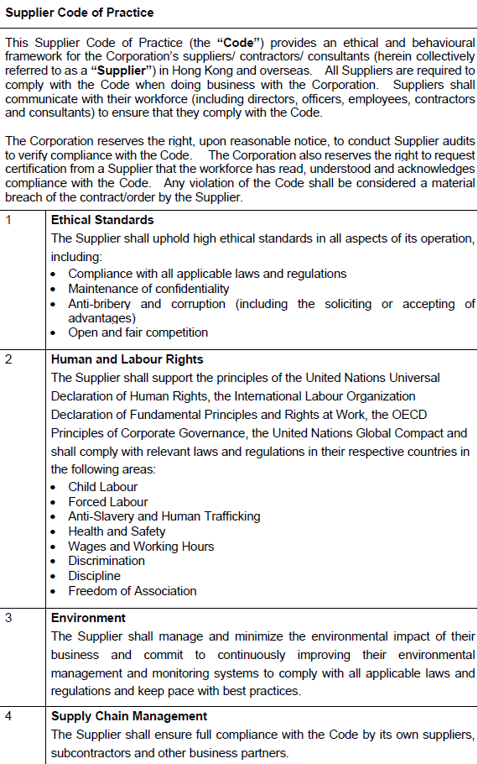
July 2022

On behalf of the management and staff, I confirm full compliance with this Ethical Code of Conduct.

(to be signed by the Chairman, CEO, Human Resources Director or a member of Senior Management)

Signature: |  |  | Date:
Name / Title: |  |  | Company:
And
Signature: |  |  | Date:
Name / Title: |  |  | Company:

