Prequalification Questionnaire for Prospective Contractors

General Instructions
The responses to Section 1 to 5 below by applicants for prequalification shall provide complete, true, accurate and up to date information required to enable the MTR Corporation Limited (the Corporation) to prequalify a company (the Applicant) to tender for the Contract(s) as described in the Prequalification Questionnaire.

When completing this Prequalification Questionnaire, Applicants shall be aware of the following conditions:

- The Corporation shall treat all responses in this Prequalification Questionnaire as confidential and undertakes not to disclose the responses to others (with the exception of the Corporation's financial, legal and insurance advisors and the Government of Hong Kong Special Administrative Region, as appropriate, during the prequalification and the tender assessment period).

- Completion of the Prequalification Questionnaire shall not bind the Corporation to invite an Applicant to submit a tender and no reasons shall be given for the exclusion of unsuccessful Applicants.

- The composition of the list of tenderers shall rest entirely with the Corporation and its decisions shall be final.

- In the event that the applicant has or may have a conflict of interest which may affect its judgment in relation to the contract or its ability to properly discharge the works or services to be delivered (including dealings with third parties), then the applicant shall immediately notify the Corporation as to the nature of the conflict or potential conflict of interest and thereafter shall discuss and agree with the Corporation what action is necessary to resolve the conflict.

- The Applicant shall not, and shall ensure that its directors, employees, agents and subcontractors shall not, offer or give any advantage as defined in the Prevention of Bribery Ordinance (Cap. 201) to any employee or agent of the Corporation. Any breach of or non-compliance of this condition by the Applicant shall, without affecting its liability for such breach or non-compliance, result in its application not being considered.

Applicant shall note the following:-

- Please fill in all cells highlighted in yellow.
- For Section 2
  - Please submit job reference and clients’ commendation (if any) in Appendix with the Item No.
  - Please insert additional lines in same format for more job reference when necessary.
- For Section 3
  - Please submit the CV of the key personnel in Appendix with the Item No.
  - Please insert additional lines in same format for more personnel when necessary.

Submitted by
Company name:

Contact person:

Telephone No.:

Email address:

Date:

Section 1
Company Profile
Year of company establishment | Established in ___________  (Please enclose copy of business and company registration)
Organization chart | Submitted in the form of Appendix by referring to Section No.
Business Nature  (e.g. event management with providing hybrid mode meeting & online interactive solutions, etc.) | Please state
No. of direct staff employed in Hong Kong

Section 2
Job references in the past 2 years (since 2024)

A) Experience to work with sizeable company (i.e. at least 5,000 employees);

B) For organising meeting with 1,500 or above on-site audience;

C) For organising related global meetings/events with hybrid mode and interactive event portal including the following services in a single event:
- Design online event portal
- HD (1080P) live streaming to different countries including Chinese Mainland, Europe and Australia
- Support multi-language (e.g. English, Mandarin & Cantonese)
- Server accessible in Chinese Mainland
- Video capturing, switching and mixing service on-site
- Provide online event portal for polling and interactive Q&A/word cloud
- Live streaming and event portal serve up to 1,000 concurrent users
- Face-to-face video conference
- Stage, LED wall, reception, lighting and audio setup in the physical venue
- Provide dedicated broadband solution to support the services

D) For providing video conferencing solutions during the events, including in-house technology or 3rd party solutions (e.g. MS Teams, Zoom, etc.)

Item A – With Sizeable Company
1 | Name of Client
 | Job Description / Scope of Services
 | Contract Period
 | No. of Employees

2 | Name of Client
 | Job Description / Scope of Services
 | Contract Period
 | No. of Employees

3 | Name of Client
 | Job Description / Scope of Services
 | Contract Period
 | No. of Employees

Item B – Organize Meeting with 1,500+ on-site audience
1 | Name of Client
 | Job Description / Scope of Services including event venue
 | Contract Period
 | No. of on-site audience

2 | Name of Client
 | Job Description / Scope of Services including event venue
 | Contract Period
 | No. of on-site audience

3 | Name of Client
 | Job Description / Scope of Services including event venue
 | Contract Period
 | No. of on-site audience

Item C – Organize Global Meetings/Events with Hybrid Mode & Interactive Event Portal
1 | Name of Client
 | Location involved
Job Description / Scope of Services
(Please also specify the details if our service requirement stated in Section 2 is met)

 | Contract Period
 | Hybrid Mode | Please state

2 | Name of Client
 | Location involved
Job Description / Scope of Services
(Please also specify the details if our service requirement stated in Section 2 is met)

 | Contract Period
 | Hybrid Mode | Please state

3 | Name of Client
 | Location involved
Job Description / Scope of Services
(Please also specify the details if our service requirement stated in Section 2 is met)

 | Contract Period
 | Hybrid Mode | Please state

Item D – Video Conferencing Solutions
1 | Name of Client
 | Job Description / Scope of Services
 | Contract Period
 | In-house technology or 3rd party solution
 | Webcasting supported by direct/in-house staff or sub-contractor staff

2 | Name of Client
 | Job Description / Scope of Services
 | Contract Period
 | In-house technology or 3rd party solution
 | Webcasting supported by direct/in-house staff or sub-contractor staff

3 | Name of Client
 | Job Description / Scope of Services
 | Contract Period
 | In-house technology or 3rd party solution
 | Webcasting supported by direct/in-house staff or sub-contractor staff

(Please insert lines for more job reference when necessary)
Section 3
Please provide structure of Proposed Project Team and CVs of the Key Personnel (including technical and non-technical team members). Please indicate their role to support the events.

Item | Name | Position | Years of Relevant Experience | CV Attached
1 |  |  |  | - Yes
2 |  |  |  | - Yes
3 |  |  |  | - Yes
4 |  |  |  | - Yes
5 |  |  |  | - Yes
6 |  |  |  | - Yes
7 |  |  |  | - Yes
8 |  |  |  | - Yes
(Please insert lines for more job reference when necessary)

Section 4
Security Measure for Webcasting Services & Online Event Portal
Any International Certified Standard for Information Security for digital data / video webcasting services obtained  (e.g. ISO standard, etc.) | (Please enclose the copy of certificate)
What kind of security measure will be implemented for the webcasting
(e.g. encryption, login, etc.)
Others
What kind of Content Delivery Network Servers will be adopted for International and Chinese Mainland?
(e.g. which service provider)
Please advise the connection speed in different points in Chinese Mainland, UK and Australia.
Please state whether the services (webcasting, event management, etc) is provided by in-house staff or sub-contractor.
Has your company worked with MTR Corporation before? | Yes / No  (If yes, please list out the job details)

Section 5
Supplier Code of Practice
Applicant is required to comply with the Corporation’s Supplier Code of Conduct. This provides an ethical and behavioural framework for contractor doing business with the Corporation.
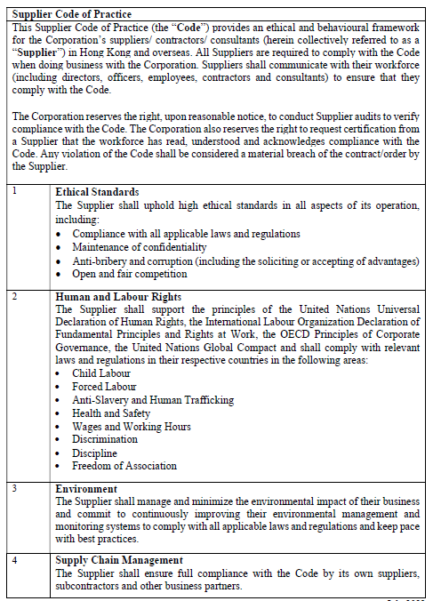

On behalf of the management and staff, I confirm full compliance with this Ethical Code of Conduct.

(to be signed by the Chairman, CEO, Human Resources Director or a member of Senior Management)

Signature: |  |  | Date:
Name / Title: |  |  | Company:
And
Signature: |  |  | Date:
Name / Title: |  |  | Company:

